QUICK REFERENCE GUIDE - How to complete a PFAS Fire Modeling request
- This document describes how to complete a fire modeling request using the PFAS program. This program will be run by trained GIS staff with the input of a Fire Behaviour Specialist (FBS). May be with the input of the rostered PWCC Fire Weather Specialist or others including Dan Perrakis, Dana Hicks or Brad Martin.

PFAS Program Setup (only have to do once on a new computer):
System Requirements:
- PFAS is a Windows-based application that will run on either a 32- or 64-bit operating system including Windows XP, Windows Vista, or Windows 7. PFAS is a computationally intense program and therefore it is recommended that you run the program on a computer with a processor that runs at a minimum of 2 GHz. It is also recommended that the computer have a minimum of 1 GB of RAM.
Windows ODBC Configuration:
- The PFAS program requires access to daily historical fire weather data. Access to this historical weather database is established using the Windows Open DataBase Connectivity (ODBC) administrator. This ODBC administrator designates the appropriate driverfor the PFAS program to access the fire weather database.
PFAS Program <--> ODBC manager<--> ODBC Drivers <--> Daily Fire Weather Database
The method of accessing the ODBC Administrator will vary depending on which Windows Operating System is currently installed.

- Windows 7 Instructions:

PFAS is a 32-bit program and therefore requires the 32-bit version of ODBC Data Source Administrator which is found at C:\Windows\SysWOW64\odbcad32.exe as shown below.

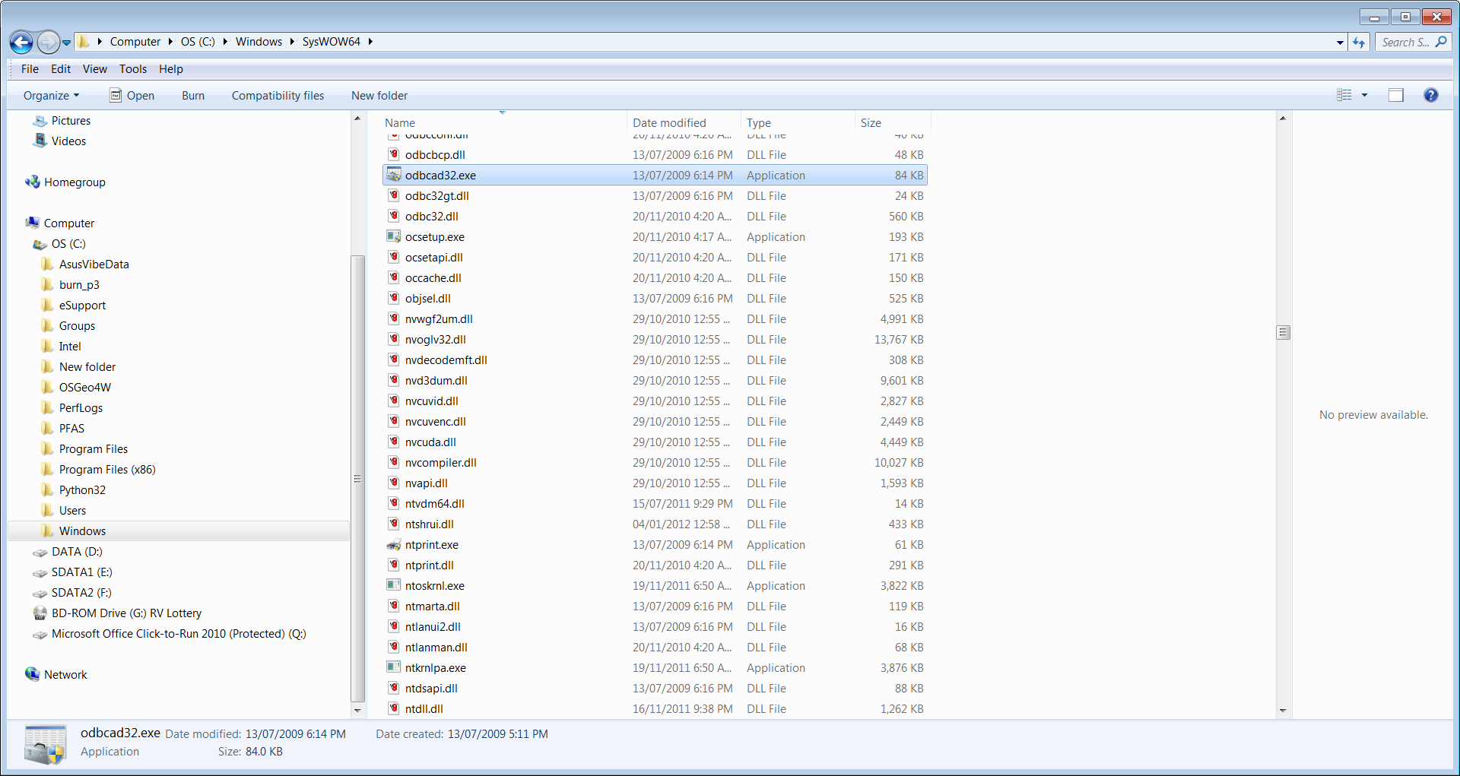

- Run C:\Windows\SysWOW64\odbcad32.exe
- Press Add button to add a new User Data Source

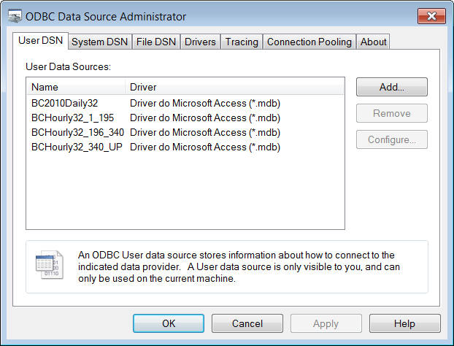

- Select appropriate database driver (in British Columbia use Microsoft Access Driver (*.mdb))

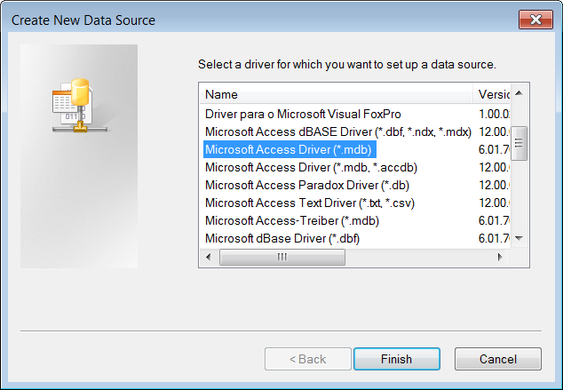
- Enter Data Source Name: such as “BCwx3”. Write down and remember this Data Source Name as you will need to enter it into the PFAS.exe parameters every time you run it.

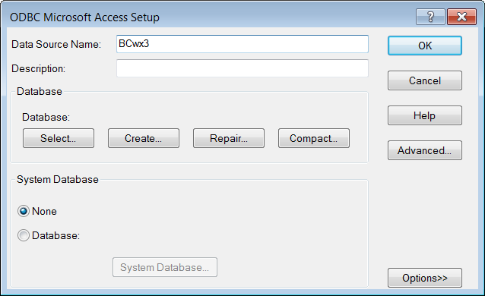

- Select Database location and file name
Press the “Select” button and select the appropriate daily fire weather database
(In British Columbia use appropriate Microsoft Access database (.mdb))

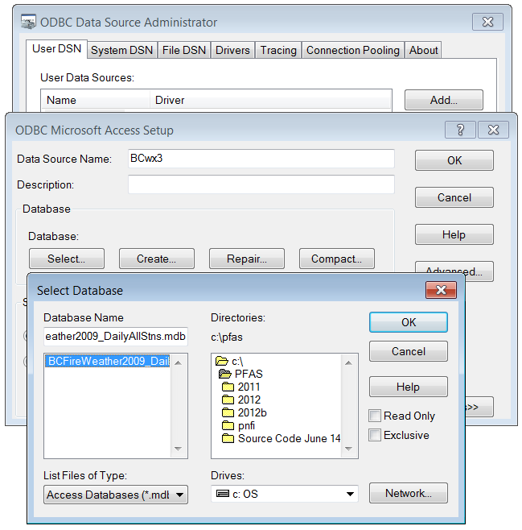

When completed, the new User DSN will be displayed as shown below.

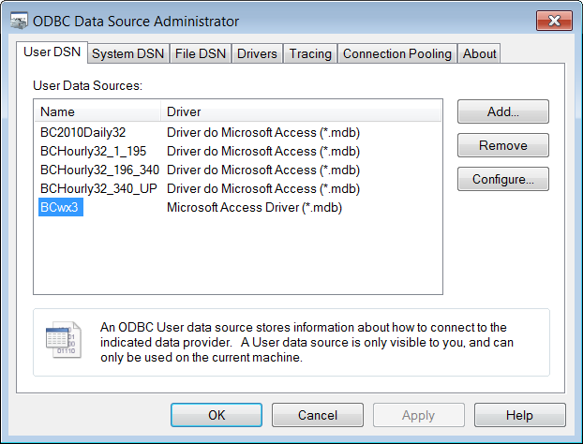

- Exit ODBC Data Source Administrator.

Press OK to exit the ODBC Data Source Administrator.

Set Up PFAS Data:

- Copy the PFAS2015 folder located here \\wildfiregeo.bcgov\Geomatics$\!Training\PFAS2015 to your own workspace. Will work quickest on local drive (C Drive). Do not run from the Y Drive folder.
- Copy and paste the ‘New Fire’ folder and rename to the fire number.
- Copy the entire PFAS data extract folder that was done from the below link and paste into the newly named fire folder. \\wildfiregeo.bcgov\Geomatics$\!Data_Exchange\Data\FireModelingData
- Open the extracted data PFAS folder and copy and paste the following files into the root of the fire number folder :
- Sort by type, copy all .GRD files (elev.grd, aspect.grd, fbp.grd, pc.grd, slope.grd, <FireNumber>.grd if a perimeter was used, may be a PDF.grd file as well) and their respective .prj files
- wxstn.dat (Copy and Replace the existing wxstn.dat file)
- If a fire perimeter was used, after copy and pasting the <FireNumber>.grd file, rename it to ign.grd. Do the same with its accompanying .prj file (‘ign.prj’).
- Open the ClimateWxStn_PFAS.kmz and the WeatherStations_Active_2015.kmz file in Google Earth from the Climate Files folder in the root of PFAS2015 folder.
- Chose the Climate weather station closest to the fire. Can also load in Fire data from \\wildfiregeo.bcgov\Geomatics$\!Publish\Data\GoogleEarth\ if not already saved in your Google Earth places.
- Once you have chosen the Climate weather station, go in to the respective Fire Centre folder in the Climate Files folder and copy the .txt file of the station chosen.
- Paste the .txt file in the root of the fire folder.
- Delete the existing CLIMATE.dat file in the root of the fire folder.
- Rename the .txt file you just pasted in of the chosen weather station to CLIMATE.dat.
- Open the wxstn.csv file and have a look at the weather stations in the list. Discuss with FBS to decide which weather stations you will be using when running the PFAS model. Guideline is 3 stations minimum and 5 the maximum, as PFAS starts running pretty slowly with over 5 station inputs. Things to look for when choosing appropriate stations include distance from the fire, and elevation in comparison to the fire. Want to get as close as possible. If a station does not make sense, don’t use it, even if you have to go with 2. This can happen in remote areas. Keep note of which stations are chosen. You can find the elevation of the fire easily in Google Earth.

Running the PFAS Model:

- Open
- Under File, Open Workspace, select the file in the root of the fire folder. Any changes you make in the PFAS model for this workspace will be saved to this .ini file.
- Follow the below guidelines for making any Edits under the Edit dropdown. (Hit OK when warned by a pop-up window by any changes you save to Recalibrate). A good practice is to go through the below steps as much as you can on your own to set up the PFAS run and then sit down with the FBS briefly to confirm all the saved changes.

Analysis Parameters:
- Guideline from Dan Perrakis right now is to Uncheck, but double check with the FBS. FBS may have some input on the number of years of data available and they may want it checked. Shouldn’t need to make any other changes.
Database Parameters:
- Make sure Data Source is set to the Data Source Name used when setting the ODBC Data Source path to the weather gdb.
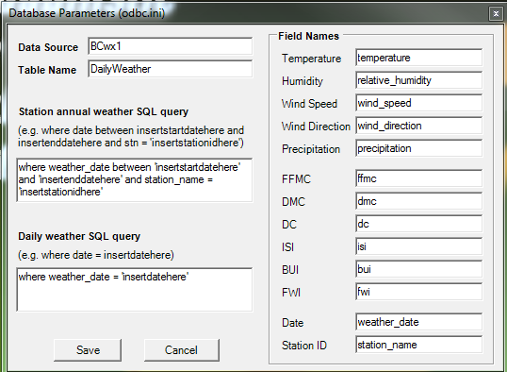
Weather Stations:
- Click in the left grey column to select and delete all listed weather stations except the ones you and the weather behavior specialist chose to use. Can just highlight and hit Delete on your keyboard.
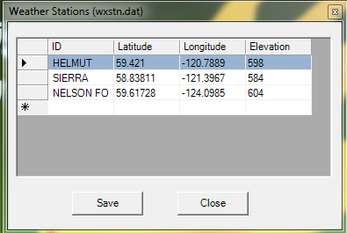
Climate Data:
- You will need to discuss any edits to the Climate Data with the fire behaviour specialist. Only worried about the month the fire has occurred and likely the one after it, but all edits to this window should be done by the FBS.
Diurnal Values:
- Shouldn’t need to Edit, leave defaults.
Values at Risk:
- Shouldn’t need to Edit, leave defaults.
Fuel Type Code:

- Shouldn’t need to Edit, leave defaults.

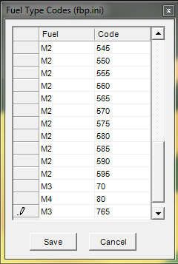

- After making all necessary edits under the Edits to parameters, run Recalibrate Modelling Environment. This may take several minutes. Troubleshoot for any errors that may arise.
- When the calibration completes it will say Process Complete, Press any key to continue and close the calibration window.
- Under Static Grids, click on Display Fuels map, have a look and make sure it’s in the right area.
- Under Static Grids, click on the Display Elevation Map, make sure it works and shows the same area as
- Run Long-Range Fire Growth Model:
- In the Long-Range Fire Growth Model window set the Ignition time to today’s date, or the date of the fire if modelling an older fire.
- Number of Days leave as the default 15
- For a DMC value can ask the FBS to supply it. You can get it from the Fire Weather tab on the BC Wildfire Service Intranet. On the Daily Weather Data page (https://bcfireweatherp1.nrs.gov.bc.ca/Scripts/Public/Common/Report.asp?Report=Daily)
- check Bounded Days
- select the closet weather station to the fire as listed in the wxstn.csv file
- Set start date and end date for a 15 day time span to get an overall view of the DMC values.
- Select what type of Report you want, the default Portrait is fine
- Click on Generate Report
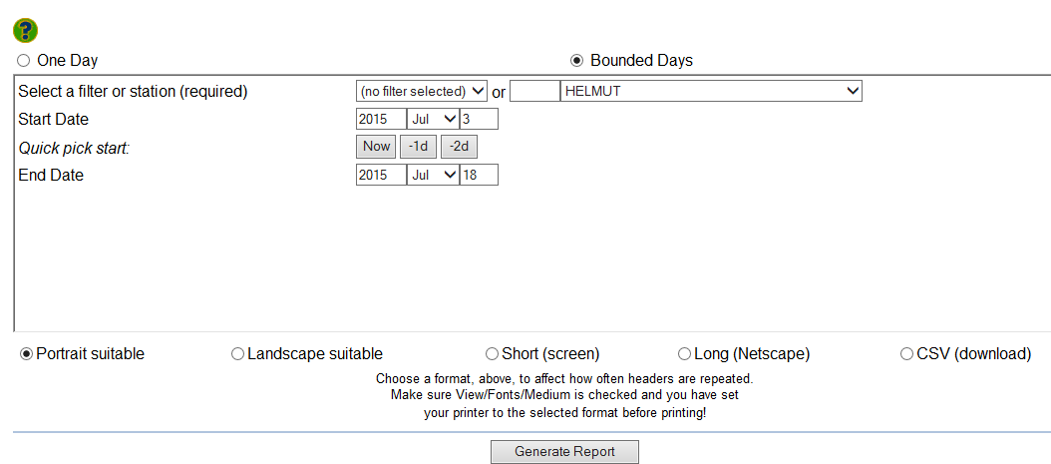
Note: There is a possibility that a different weather station used I the model may show a very different DMC value. It can be worthwhile having a look at a few of the surrounding weather stations DMC values, especially if there are a few close by and relevant to the fire. Ultimately it is the FBS decision what the final DMC value input is.

- Minimum Probability (%) set to 30 always.
- If a perimeter was used in the data extract and there is a ign.grd file associated with it, under Ignition Location check ‘Use ignition grid’. If no fire perimeter is available, make sure the Use this location is set to the Lat and Long of either the fire point in Dispatch or to coordinates provided by the FBS. Also fill iln Size (ha) from current fire data. Double check Ignition Location information with FBS if model is not using a ign.grd file.
- No changes need to Map Extent.
- Hit Run. (Have to click on it twice). This may take several minutes.
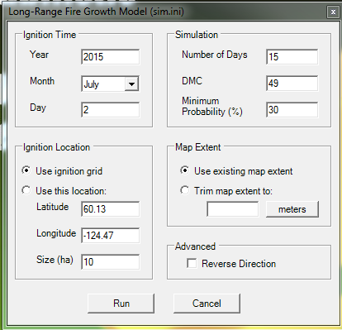
- After model has run, click on Statistics under the Reports tab to produce the stats report you will pass along as an output.
- In the root of the fire folder you will find the outputs of the PFAS model. Only two files do you need to copy and paste into the respective Y Drive Fire Folder. Sort by Date Modified so the last files created come to the top.
- Rename stats.rpt to stats.txt
- Copy stats.txt and pfin.grd files.
- Create a new folder titled YYYMMDD in the Data\Incoming\PFAS folder for your respective fire and paste the pfin and stats file into it.
- Create the Final PFAS map as per usual. Create KML file using new PFAS to Poly model, and convert the poly to a kml. Pass along links to the Final PFAS map, the KML PFAS projection file and the stats.txt file to the FBS.

Further Information:
\\wildfiregoe.bcgov\Geomatics$\!Training\PFAS2015
<PFAS_User_Manual_22.doc>
<PFAS Cheat Sheet_2015.docx>

TO DOs and Other Random Notes – work in progress:
- Potentially create an email/form template of the information needed from the FBS when running PFAS model.
- Clean up this guide with highlighted boxes\checklist of what to talk to FBS about.
- Clean up Fire Modeling folder and combine QR guides where logical.

- When you create the fuels map prior to running PFAS, have the fire behaviour specialist have a look at it to see if there are any manual changes that they want to make to the PFAS fuels grid file (fbp.grd). For example if there are creeks or rivers near the fire that would impact the projection of the fire, the fire behavior specialist may decide that it is not a big enough fuel break and that the fire could jump the water body. In this case the fbp.grd file will need to be manually edited to incorporate any avenues for fuel across the water. With the river example, it may be that a few narrow patches of grass fuel are added to the fuels layer so that the fire may jump across in the projection. This is something that is completely up to the fire behaviour specialist, and they will need to decide on the edits, and are likely to do them themselves if needed. So far as we know at this time, we are unable to edit the fbp.grd file directly, but it can be done in Prometheus and brought in to PFAS, but this is a more advanced process and fire behaviour specialist must have Prometheus knowledge.
- On the same note, it is easiest to edit the Fuel Type Codes in fdp.ini to be a different coded value if need to make changes on the whole. But rarely applicable.
- If you have to re-run the model if changes are made to the fuels layer and the PFAS model has already run once, delete tht GIF and GWF files for fuels so the Fuels Map will run again with the updates.
- If you have run PFAS model once and needed to make changes and rerun it, it should overwrite the first output files. If you run into errors you cannot remedy, best bet is to re-copy the folder and data extract and start fresh.

Document Change Tracking
Version | Date of Issue | Author(s) | Brief Description of Change
1 | June 2015 | Glenna Erlandson | - Document creation

